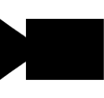

2019 version made by Hugo Fournier, Adrien Germain and Gauthier Leclercq

Based on the 2014 version made by Thomas Dubrulle and Antonin Durey

With Tomas Holt, Grethe Sandstrak, Alexander Holt and J.H. Nilsen

Camera Manager

User guide

Table of contents

I. General explanations 4

II. The main interface 5

III. Camera interface 6

1. The camera tab 6

2. The toolbar 7

3. Camera Sub Window 7

IV. Project interface 8

1. The project tab 8

2. Right click 8

V. The option file 9

1. Raw text mode 9

2. The wizard mode 9

VI. The calibration file 11

1. Main presentation 11

2. The text view 12

2.1 Right Click 12

2.2 Right Click 12

3. The table view 14

VII. The socket file 15

1. What is the socket file 15

2. The text view 15

3. The table view 15

3.1. Presentation 15

3.2. Right click 16

VIII. The grupper images 17

Appendix n°1: TrackPoint File Dialog 18

Appendix n°2: Combination calibration summary 19

Appendix n°3: Grupper Image 20

# I. General explanations

Camera Manager is a software which help camera configuration and 3D data visualization. In fact, it works with TrackPoint, which is a 3D detection software.

TrackPoint gets two types of runs:

- The first takes the option.txt file in input, calibrate the cameras, and show the calibration results in some files, which the main is the “*calibration_summary*” file.

- The second works with this file and the option.txt file. It takes images for the 3D detection either from the cameras, or from existing images named *grupper images*. The second run generates many files for each time, a resume of the coordinates which are the socket files and some others.

Before, there wasn't a graphical interface to show the coordinates, and the configuration had to be done manually. Camera Manager allows you to check cameras and their properties, edit calibration files, and show the 3D data in several views. Moreover, with it, you have access to a wizard and a text view that simplifies the edition of the configuration file.

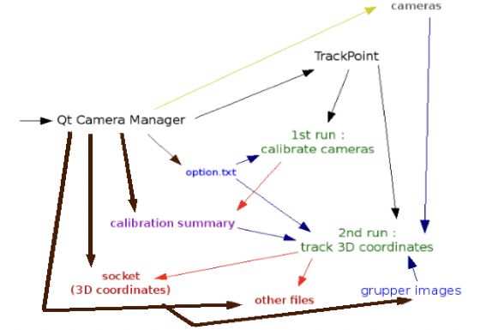

# II. The main interface

The main interface is made of 3 parts:   
- The red part is the toolbar. It provides actions for the visualization of the images coming from cameras. This is explained in details on page 7.   
- The blue part is the tab part, called *Left Menu*, in the software. There are 2 tabs: the project tab and the camera tab. Here, it is the project tab that is selected. It is only composed of a tree view. The camera tab is composed of a tree view and a table to show and change the camera parameters. The tabs are respectively explained on pages 8 and 6.   
- The black part is the part where sub windows are. It can be sub windows for the cameras, the configuration files and more. Each sub window is described in its own part.

A fourth part can be counted. It is the menu bar, which is up the tool bar but not shown on the image. The menu bar provides actions with key shorts to help using Camera Manager. Each action will be explained later in the user guide.

In order to have a better view on sub windows and their contents, you can hide the toolbar and the tab part. Use the menu bar (*Window* →*Hide ToolBar* or *Hide Left Menu*) or use the key combination *Ctrl+H*, *Ctrl+T* for the toolbar, or *Ctrl+H*, *Ctrl+M* for the left menu.

# III. Camera interface

## The camera tab

**1:** This is the menu where you can choose the API you want to run. Currently, there are two choices: *Fly Camera Manager* which runs the FlyCapture API and *Spinnaker Camera Manager* which runs the Spinnaker API.

**2:** This is a tree where all the found cameras will be. For both of the managers, each time you plug or unplug a camera, the software will automatically detect it and update the tree.

To select a camera, just click on its name. If you want to watch the images coming from this camera, tick its corresponding checkbox and a sub window will appear on the right (more details further).

Performing a right click on it pop up a menu, which is shown on *Figure 2.* With it, you can *add* and *remove* a camera group. This can be very useful if you have several cameras and want to sort them by combination. You can also *edit* and *reset* the name of a camera.

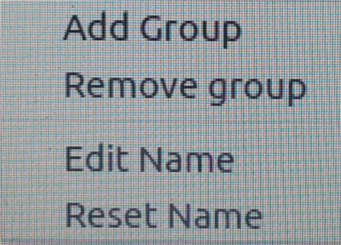**3:** This is the name of the camera which is currently selected. if there is no camera selected, *No Selection* will be written.  
**4:** This is the table with the selected camera properties. The camera **must** be recording to have properties updated. There are fourth columns per property:

Figure 1 : Camera tab

- the *property* name

- the *auto* box: checking the checkbox allows you to set the value. Leave it unchecked if you want the camera to auto-adapt the value itself.

- the *value:* the integer value of the parameter corresponding to the slider position.

Figure 2 : Right click on camera tree

- the *slider:* let you change the value between the minimum and the maximum values.  
**Note: Depending on the manager you choose and the camera you use; some properties**

**may not exist, have different names and/or have different minimum/maximum values.**

## The toolbar

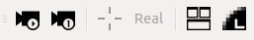

Figure 3 : Toolbar

This is the toolbar “menu”, at the top of the frame, just below the menu bar. It provides six actions. From left to right:

- *Live View:* start, or stop the live view. If you changed properties in the properties box, the stream from the camera will have their properties updated.

- *Update Image:* get one image from the camera to display it in a sub window.

- *Cross hair:* if *Live View* is enabled, draw X and Y axis according to you mouse position to help you get the coordinates of your mouse pointer. These coordinates will be displayed at the top left corner of the sub window. You can see more details on that function further.

- *Integer coordinates:* show coordinates with integers and not decimal numbers.

- *Mosaic view:* once clicked, all sub windows will be stretched to fill all the space.

- *Quality:* Change the quality of the pictures. Be careful: this function causes high CPU usage.

**Note**: the toolbar can be hidden (to get more space) by using the menu bar (*Window* →*Hide ToolBar*) or by performing the keyshort *Ctrl+H*, *Ctrl+T*.

## Camera Sub Window

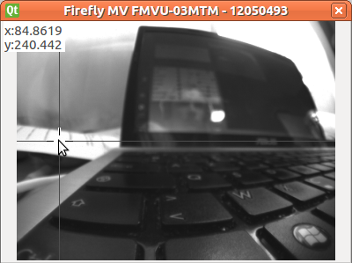To open a camera sub window, check the box corresponding to the wanted camera. A subwindow will appear with the name of the camera as its title (e.g. *Firefly MV FMVU-03MTM).*

Figure 4 : Camera Sub Window, with live view and cross hair activated

You can’t resize the window but you can set the mosaic view to have a better view of the images.

The figure 4 gives you an example of the sub window once the live view is enabled. Note that crosshair and coordinates functions are enabled.

# IV. Project interface

## The project tab

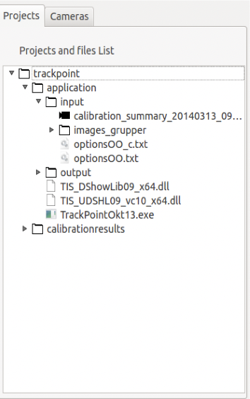The project tab is only made of a tree view. This tree view allows you to load your TrackPoint project. To ensure that your project will be loader properly, please note that the name of your project folder has to contains the word “*trackpoint*”. It doesn’t have to be only the word “trackpoint”, you can name it as you wish as long as it contains that word.

Figure 5 : project tree, with the trackpoint folder

On the Figure 5, you have an example of the files you can open with the Camera Manager software:

- the “*calibration_summary”* file which is a summary of the calibration settings.

- every group of images, all contained in the “*images_grupper”* folder,

- options file(s)

- the socket file(s), located in the *output* folder, totally at the bottom of it.

Please note that every item is sort by alphabetical order. If you are unable to find a file, double check that you are on the right folder where you are supposed to find it.

## Right click

Performing a right click on the project tree will pop up a menu with two actions:

Figure 6 : right click on project tree

*- Load project*: open a window for you to search and open your directory (see Appendix 1: Trackpoint FileDialog).

- *Close project*: remove the selected project from the project tree.

# V. The option file

When you open an option file, a new window will appear. It allows you to choose between two mode: the wizard mode and the raw text mode.

## Raw text mode

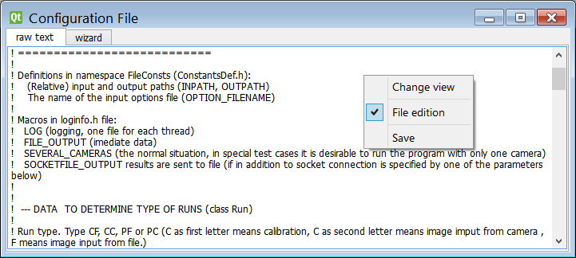

Figure 7 : Window of raw text mode

In the raw text mode, you can see you the file directly and modify it. You can use the right-click to change the view between *raw text* mode and *wizard* mode, to allow or prevent editing the file or to save the file.

Use this mode if you want to have a total control over the option file or if the structure of the file has changed significantly since the release of the software (June 2014) and the wizard doesn't work properly anymore. For other cases, you should use the wizard mode.

## The wizard mode

The wizard mode is composed of a list of fields you can edit. There are multiple types of fields, allowing you to edit the most important values of the configuration file. All of these values are limited to the type they normally are.

By performing a right click on the window, you can open a menu to switch view, allow or prevent file edition, to save the file and finally to display all parameters in the wizard.

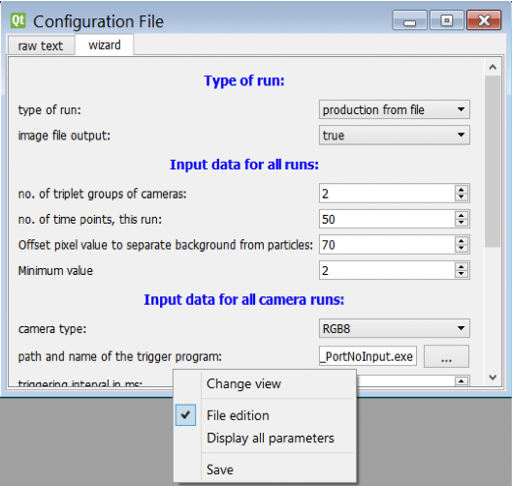

Displaying all parameters in the wizard show all the parameters available in the configuration file. It may be used when you wish to access a parameter which is more rarely used. Be careful to respect its type when editing one of these, as no control will be provided.

It is possible to change manually what parameters will be seen in the wizard by modifying parameterList.txt. You can find more information on how to do it in the aforementioned file.

# VI. The calibration file

## Main presentation

The *calibration_summary* file is a summary of all the calibrated combinations during the first run of Trackpoint. Let's cut this file into pieces to explain how it works.

Figure 8 : calibration_summary file

**1:** The *Groups* line is the combination which will be used for the second run of TrackPoint (here, *1_2_5* and *0_3_4*). Can be changed (more details further).

**2:** the directory where the grupper images are.

**3:** the camera lines, with their serial number

**4:** some information

**5:** The summary of each combination (Bold, Italic and Underline explained further). The lines with “NO CONVERGENCE” are combination which cannot be used for the run. The lines are sorted with the parameter written at the *6*. These lines can be sorted, changed, hidden to choose the best combination(s). See further to learn how to do it.

## Text view

The text view is just a basic view of the calibration_summary file, with several options, reachable with right and left click

### page12image57586882.1 Right click

Performing a right click on the project tree will pop up a menu with three available actions:

- *Go top:* bring you to the top of the file.

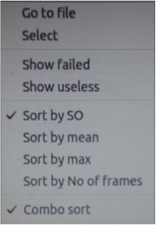- *File edition*: allow or prevent file edition. Please note that the first time you will open a summary file, the edition will be disable in order to prevent unwanted modifications. You have to turn it on if you want to edit the file.

Figure 9 : right click on text view

- *Save:* save the file. Please note that there is no autosave feature. If you don’t save the file, all the modifications will be lost.

2.2 Left click

The left click provides a menu if you are clicking on “summary lines” (see number **5** in figure *8*).

A menu similar to the figure 10 will appear:

- *Go to file:* bring you to the selected combination calibration summary (more details in Appendix 2: Combination calibration summary).

- *Select:* select the current line. Only available for lines that are not failed, or reversed line that are not failed. Take back the *Figure 8* from last page, you can only select the lines which are not underlined. Selecting a line will try to compute what other lines can be set as “useless”. E.g. if you select 1_2_5 combination, all the combinations with the camera n°1, 2 or 5 would not be useful longer. The “useless” lines are the thin ones. The selected lines are in bold. The only line which is not changed is the 0_3_4, which is the opposite from the 1_2_5 combination.

Figure 10 : left click on text view

- *Show failed:* show, or hide the failed line (“Failed line” are lines with “NO CONVERGENCE”) and their opposite. E.g. in the *figure 8,* it is the underlined lines (for example: 1_2_3 and its reverse, 0_4_5). With this option enabled, the lines would not be shown.

- *Show useless:* show, or hide the useless lines. E.g. in the *figure 8,* the “useless” lines are the thin one. With this option enabled, the lines would not be shown.

- *Sort by SO/mean/max/No of frames:* let you sort the combinations by the parameter of your choice. By default, the first parameter is always SO. If the option “Show failed” is enabled, the sorting process may not be completely accurate. E.g. in the Figure 8, the lines are sorted by SO, according to the line at number **6**.

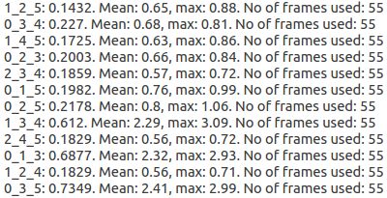- *Combo sort:* only available with 6 cameras. Take the lines with their opposite, compute the sum of the parameters which the sort must be done by; and sort the result. With the Figure 10, the lines would be sorted by SO, with their opposite.

In the figure 11, you can see an example of the SO combo sort. 1_2_5 and 0_3_4 SO parameter sum is 0.3702, which is the lowest, then come 1_4_5 and 0_2_3 with 0.3728, 2_3_4 and 0_1_5 with 0.3841....

Except, *Go to file*, all the left click actions are disabled while file edition is disabled. You will probably allow *File edition*, watch the lines, especially the failed ones and hide them. Only at that moment, you will be able to sort the lines as you want.

Figure 11 : combo SO sort

You can also click with the left button of the mouse on a path line of a combination calibration file (see below *Illustration 11*). Left click will pop up a menu with a simple action: *Change View*. Clicking on it will change the view from text view to table view.



Figure 12 : path line of a combination calibration file with the combination 0_1_2

## page14image5313824The table view

Figure 13 : Table View of the combination 0_1_2

The table view is a better way to show the different parameters of each cameras in the combination. It does not show the generic parameters (SO, mean, max, and No of frames).

On the left, there is a graphical component where you can read which cameras corresponds to which lines, their ID and their serial number.

On the right, the graphical component sums up all the parameters, and their value, for each camera.

There are many parameters (around 27), and all of them cannot be shown at the same time in the screen. However, a scrollbar (not shown on the illustration) at the bottom allows you to scroll to the left or to the right part of graphical component. The left graphical component does not move, which is to have a better view on which parameters and which values belong to which camera.

# VII. The socket file

## 1. What is the socket file

The socket file is the file where all the coordinates, for each camera and at each moment, are. The file is named: “*socket_[year][month][day]_[hour][minute][second]”*, with year, month, day, hour, minute and second as the current time when the file is created. You can see an example of the socket file in text view mode in the figure 14 below.

## 2. The text view

The text view is just a basic view of the *socket* file. This view is not practical because the coordinates at one time take 2 lines, so it is really not easy to read and know which camera is it, which axis and which time. Right clicking will pop up a menu with a single option: *Change View*, which will switch from text view to table view.

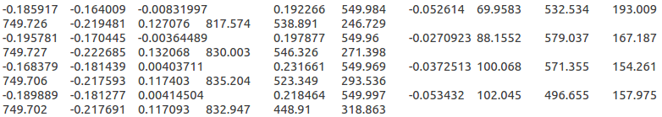

Figure 14 : text view

## 3. The table view

### 3.1. Presentation

The table view is a view which allows you to easily watch the coordinates. It is composed of 3 graphical components:  
  
- the left and right component are the time axis.   
  
- the central component is a table. one line per time, and 3 columns for a point (for the x, y and z axis respectively). The points have a background (white or grey) to easily make the difference between them. When you scroll up/down, the time and the central area will automatically scroll together.

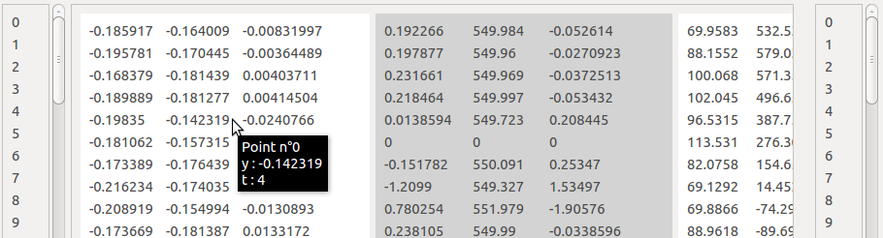

Figure 15 : socket table view, with point number, axis, value and time

When you move you mouse over a coordinate, a tooltip appears, informing you what point is it, the axis, the value and the time of the coordinate. On the Illustration 14 below, the mouse is on the cell line 4 column 2: it is the point n°0, axis is y, value is -0.142319 and time is 4.

### 3.2. Right click

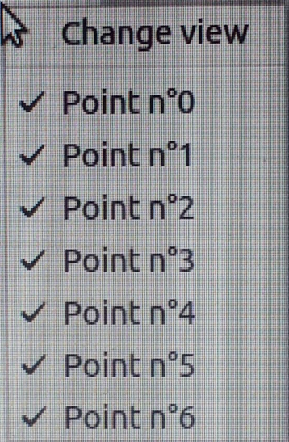If you do a right click on any line, a pop up menu will appear letting you choose between several options:

Figure 16 : right click on calibration table view

- *Change view:* change the view from table view to 3D view.

- Point n°0/1/2...: there are as many items as points. These items are checkable. If the item is checked, the point is shown. If not, the point is hidden. This can be very useful if you are interested in some points only. In the opposite illustration, all the points are shown.

# VIII. The grupper images

The grupper images are the images with the one you can make the second trackpoint run with. See Appendix 3: Grupper image if you need more details about that.

Clicking on a point will pop up a tooltip with the point information: the camera it is taken from, which point it is, and its coordinates on the image.

In the image below, the point is taken from Camera n°0, it is Point n°5, X-axis coordinate is 806 and Y-axis coordinate is 402.

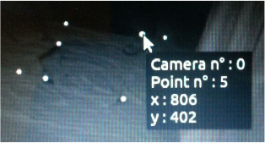

Figure 17 : grupper image, clicking on a point

# Appendix n°1: TrackPoint File Dialog

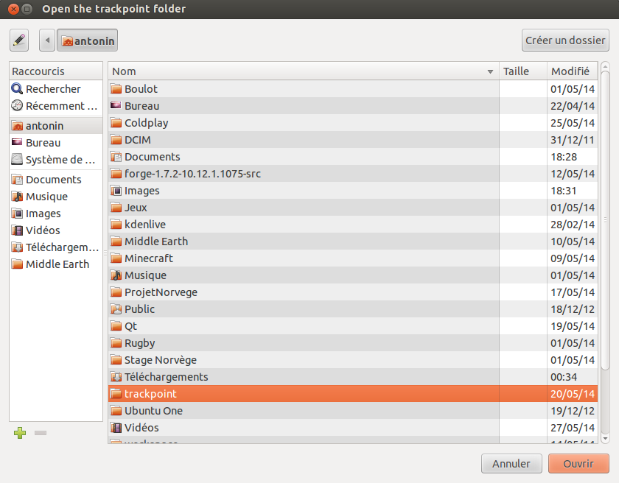

The File Dialog opens when the *Open Project* action is performed. You can navigate through your computer. Find your TrackPoint folder or another folder containing “trackpoint” in its name. Then, click on 'Open' to open it in the project tree.

# Appendix n°2: Combination calibration summary

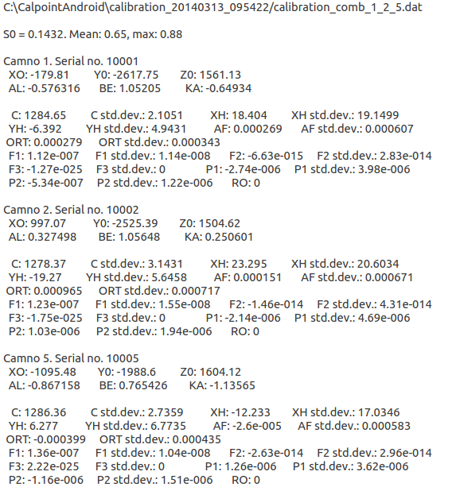

This is an example of a combination calibration, which is contained into the *calibration_summary* file. Here, the combination is **1_2_5**. In this example, this file is also an existing file, its path is on the first line. Next, come the information you can also read at the beginning of the *calibration_summar*y file: SO, mean and max. then, for each camera in the combination, you can see several parameters, as XO, YO, ZO, AL...

# Appendix n°3: Grupper Image

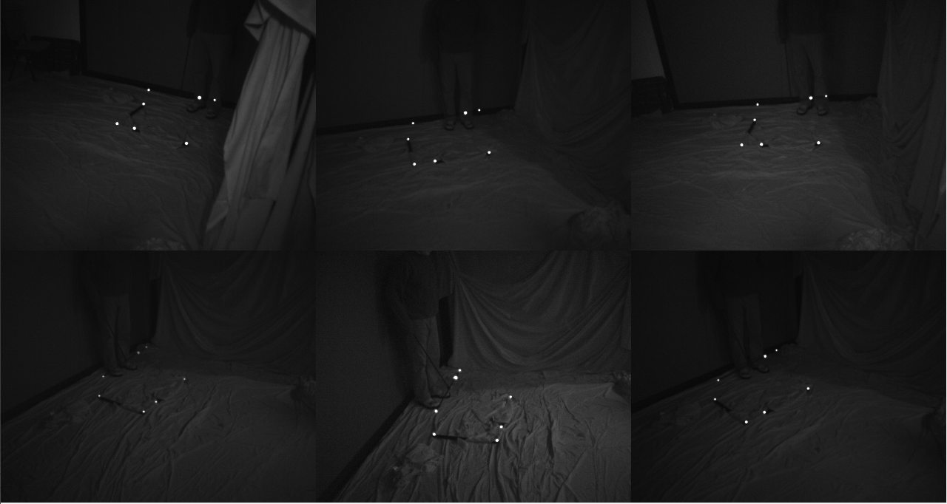

There are 6 different images because there are 6 cameras. Please note that no matter how many cameras you plugged in, it will always be 3 cameras per line.

The white points are the points detected during the run of TrackPoint.